**DBMS LAB TASK-4**

**Name: Kommaraju Jahnavi**

**Reg No. : 121910306007**

**Section: B6**

**SAILORS DATABASE**

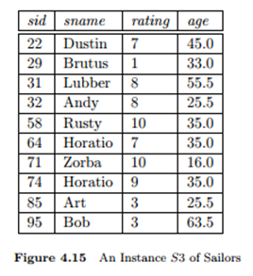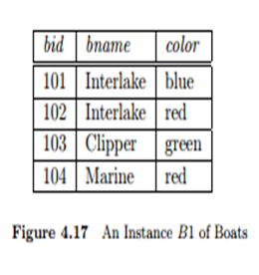

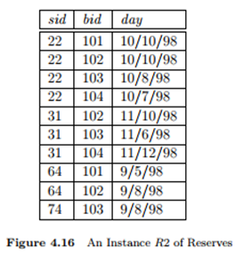

1. **CONSTRUCT an ER MODEL FOR SAILORS DATABASE WITH CONSTRAINTS**

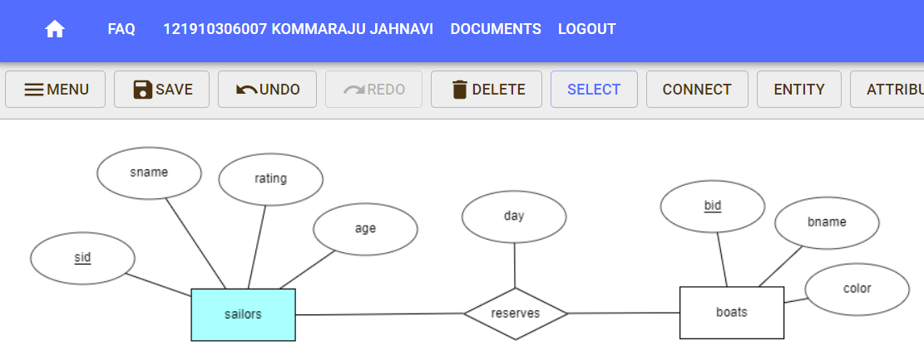

1. **CREATE A TABLES FOR SAILORS DATABASE WITH CONSTRAINTS**

**For SAILORS Table:**

**CREATE TABLE SAILORS(SID INTEGER PRIMARY KEY, SNAME VARCHAR(10) NOT NULL, RATING INTEGER, AGE INTEGER);**

**Output:**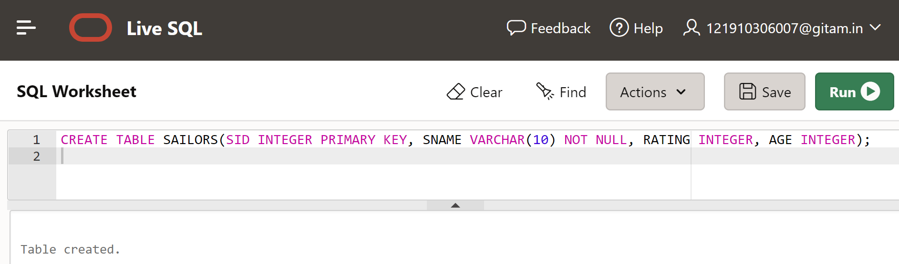

**For BOATS Table:**

**CREATE TABLE BOATS(BID INTEGER PRIMARY KEY,BNAME VARCHAR(10) NOT NULL,COLOR VARCHAR(10));**

**Output:**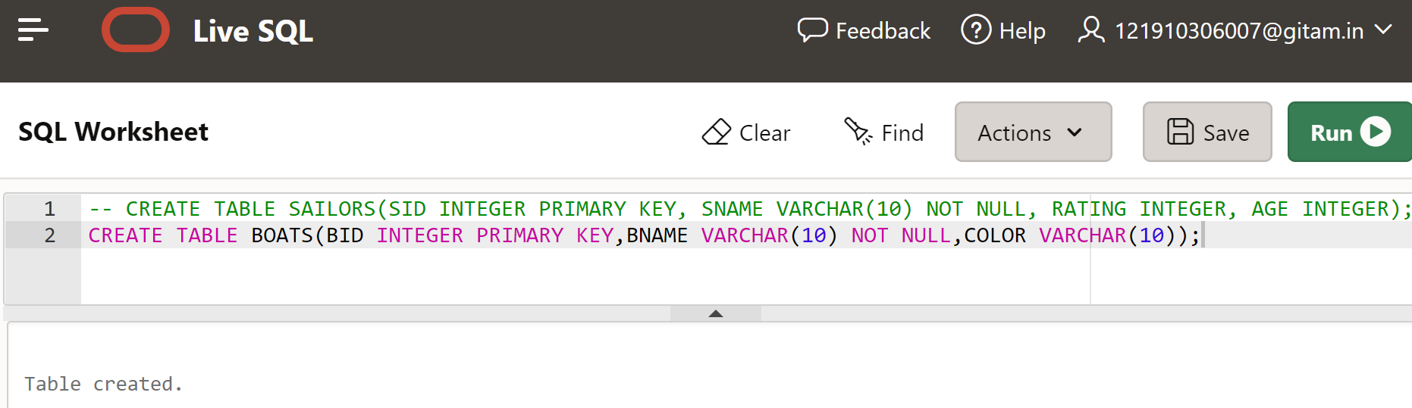

**For RESERVES Table:**

**CREATE TABLE RESERVES(SID INTEGER , BID INTEGER,DAY DATE NOT NULL,PRIMARY KEY(SID,BID),**

**FOREIGN KEY (SID) REFERENCES SAILORS,FOREIGN KEY (BID) REFERENCES BOATS);**

**Output:**

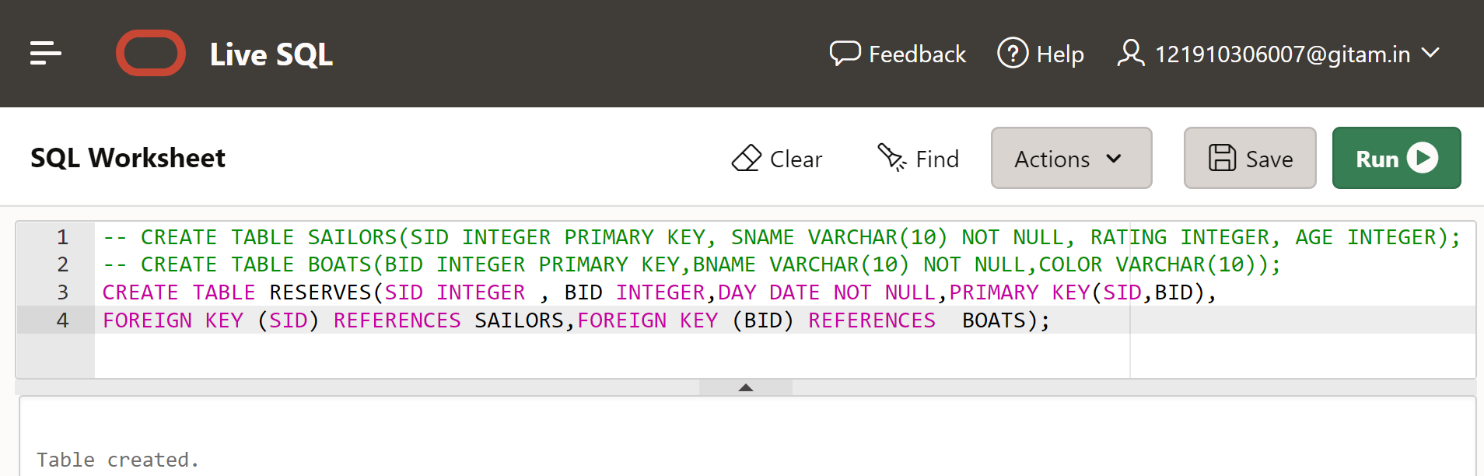

1. **INSERT THE VALUES IN RELATIONS**

**For SAILORS Table:**

INSERT INTO SAILORS VALUES(22, 'Dustin', 7, 45.0);

INSERT INTO SAILORS VALUES(29, 'Brutus', 1, 33.0);

INSERT INTO SAILORS VALUES(31, 'Lubber', 8, 55.5);

INSERT INTO SAILORS VALUES(32, 'Andy', 8, 25.5);

INSERT INTO SAILORS VALUES(58, 'Rusty', 10, 35.0);

INSERT INTO SAILORS VALUES(64, 'Horatio', 7, 35.0);

INSERT INTO SAILORS VALUES(71, 'Zorba', 10, 16.0);

INSERT INTO SAILORS VALUES(74, 'Horatio', 9, 35.0);

INSERT INTO SAILORS VALUES(85, 'Art', 3, 25.5);

INSERT INTO SAILORS VALUES(95, 'Bob', 3, 63.5);

**Output:**

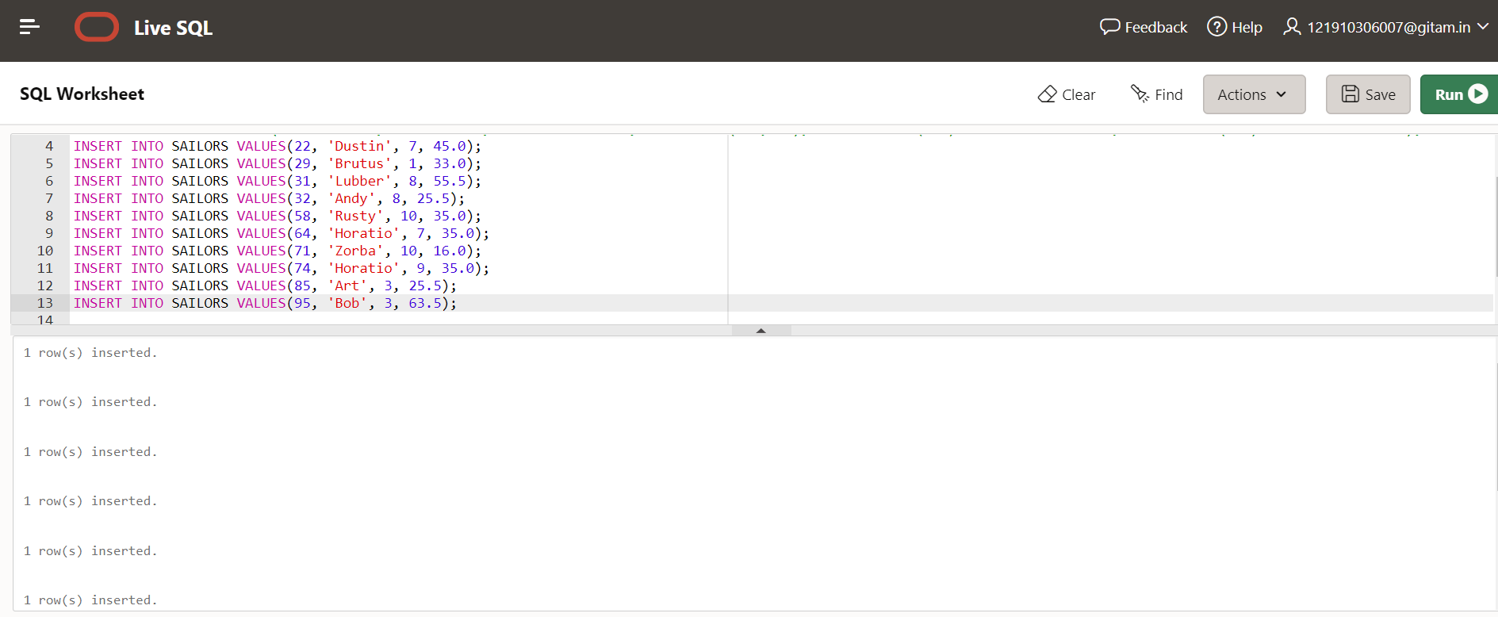

**For BOATS table:**

INSERT INTO BOATS VALUES(101,'interlake','blue');

INSERT INTO BOATS VALUES(102,'interlake','red');

INSERT INTO BOATS VALUES(103,'clipper','green');

INSERT INTO BOATS VALUES(104,'marine','red');

**Output:**

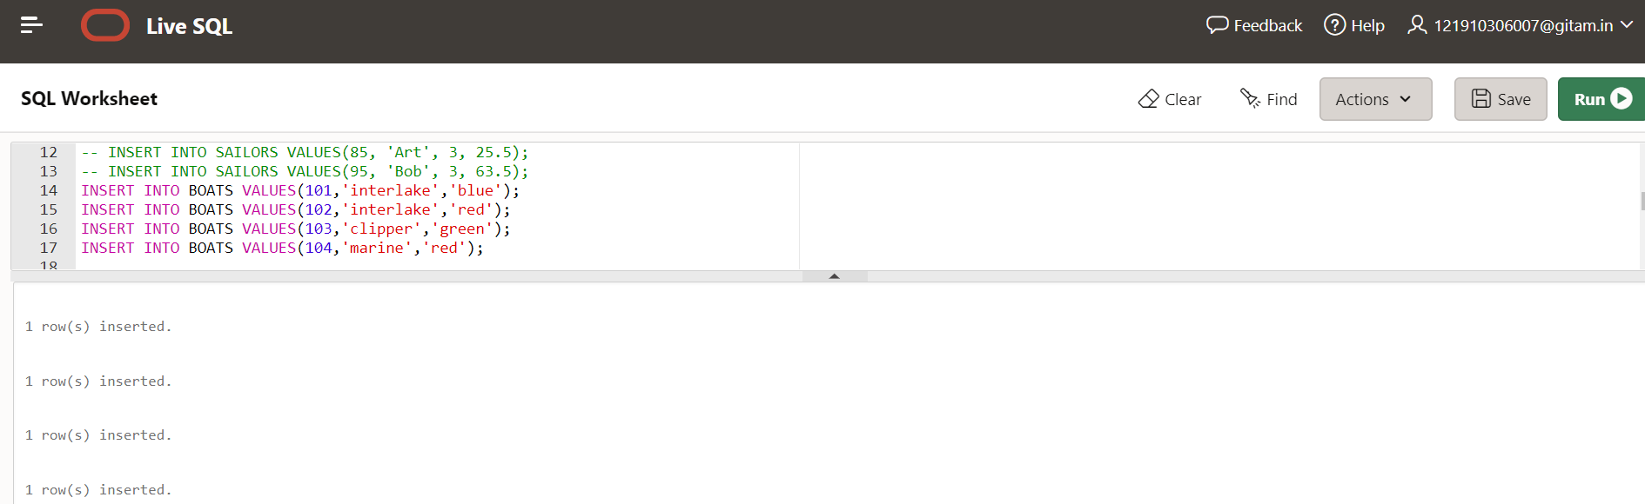

**For RESERVES table:**

INSERT INTO RESERVES VALUES(22, 101, '10/OCT/98');

INSERT INTO RESERVES VALUES(22, 102, '10/OCT/98');

INSERT INTO RESERVES VALUES(22, 103, '10/AUG/98');

INSERT INTO RESERVES VALUES(22, 104, '10/JULY/98');

INSERT INTO RESERVES VALUES(31, 102, '11/OCT/98');

INSERT INTO RESERVES VALUES(31, 103, '11/JUNE/98');

INSERT INTO RESERVES VALUES(31, 104, '11/DEC/98');

INSERT INTO RESERVES VALUES(64, 101, '9/MAY/98');

INSERT INTO RESERVES VALUES(64, 102, '9/AUG/98');

**Output:**

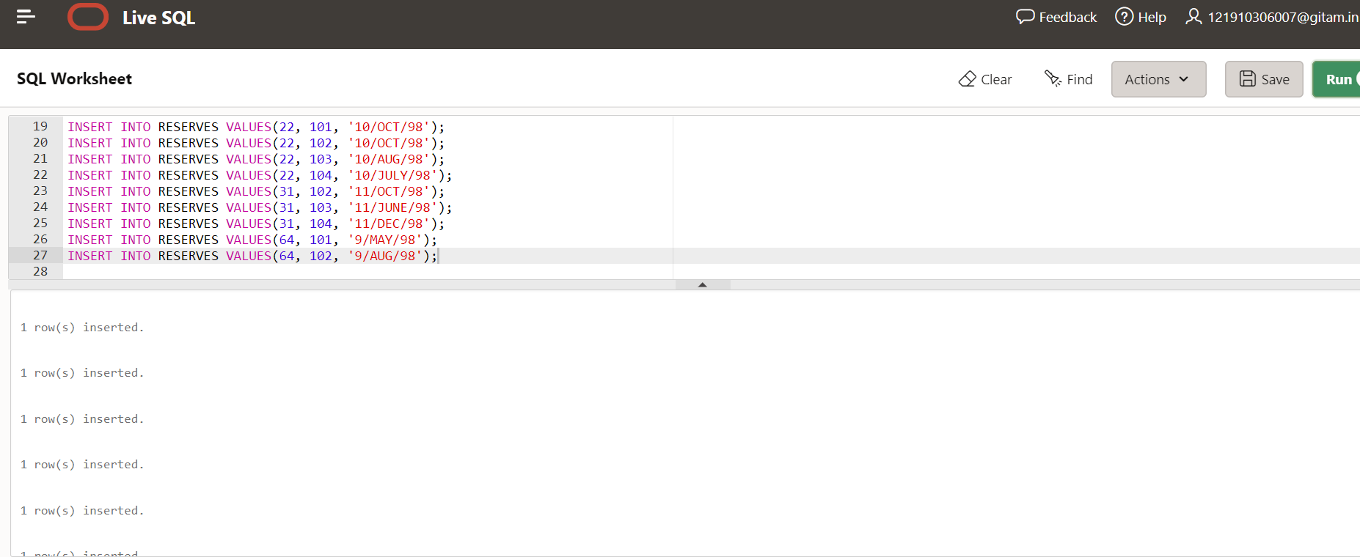

1. **DISPLAY THE RELATIONS**

**For SAILORS table:**

**SELECT * FROM SAILORS**

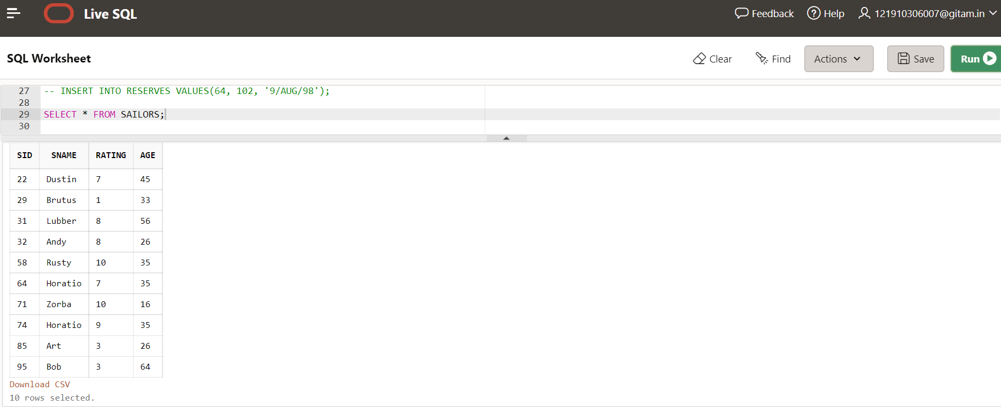

**For BOATS table:**

**SELECT * FROM BOATS**

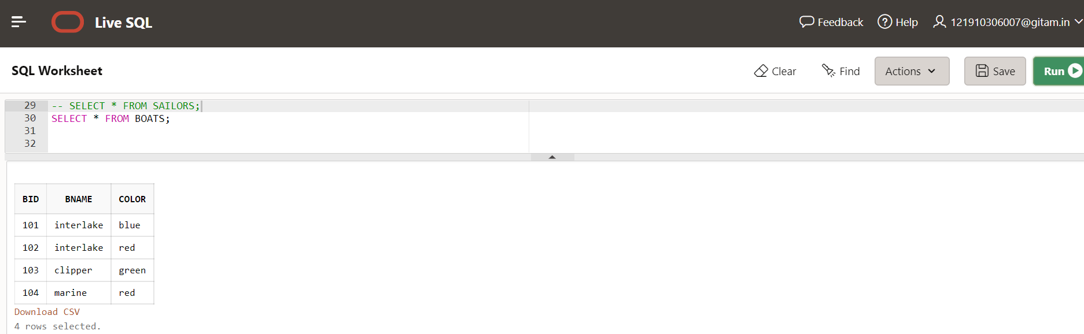

**For RESERVES table:**

**SELECT * FROM RESERVES**

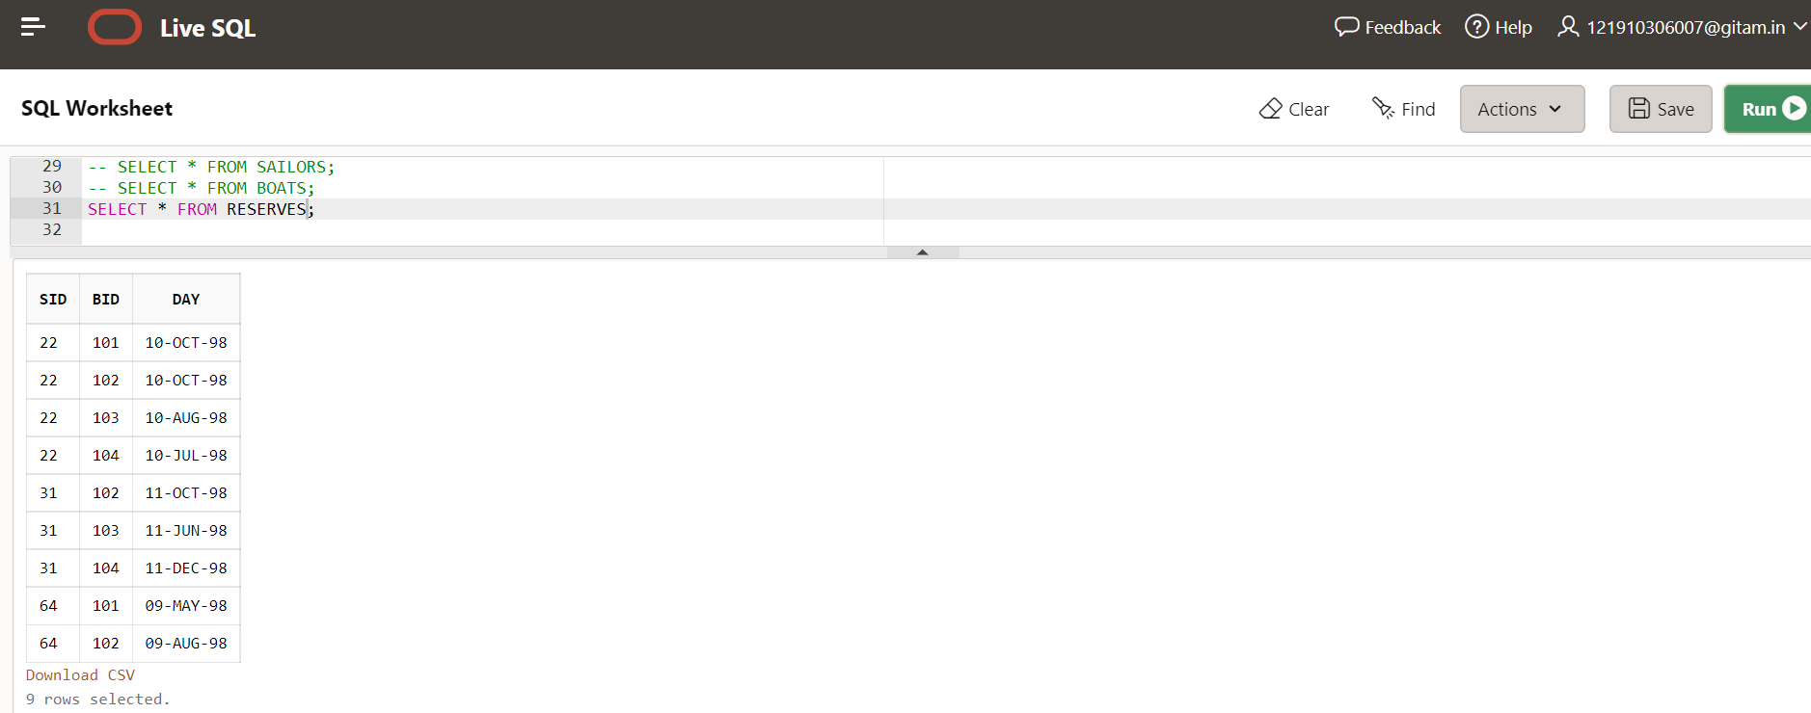

**QUERIES**

1. **Find the Names and ages of all sailors?**

**SELECT SNAME, AGE FROM SAILORS S;**

**Output:**

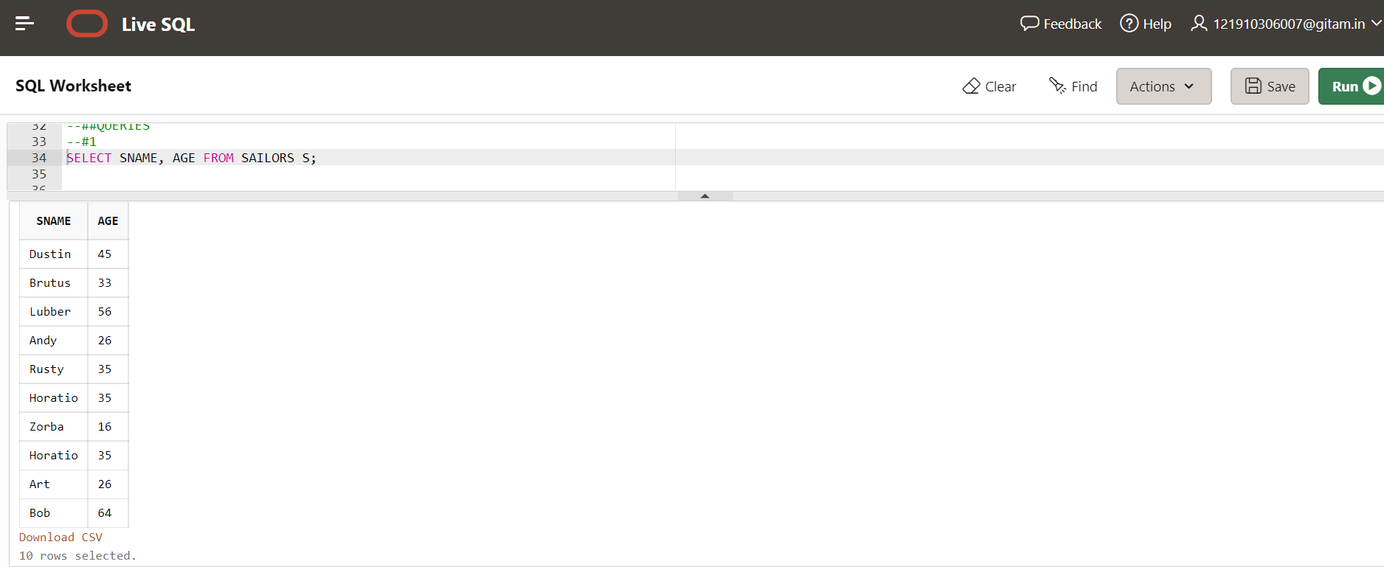

**2) Find all sailors with a rating above 7?**

**SELECT* FROM SAILORS S WHERE RATING>7;**

**Output:**

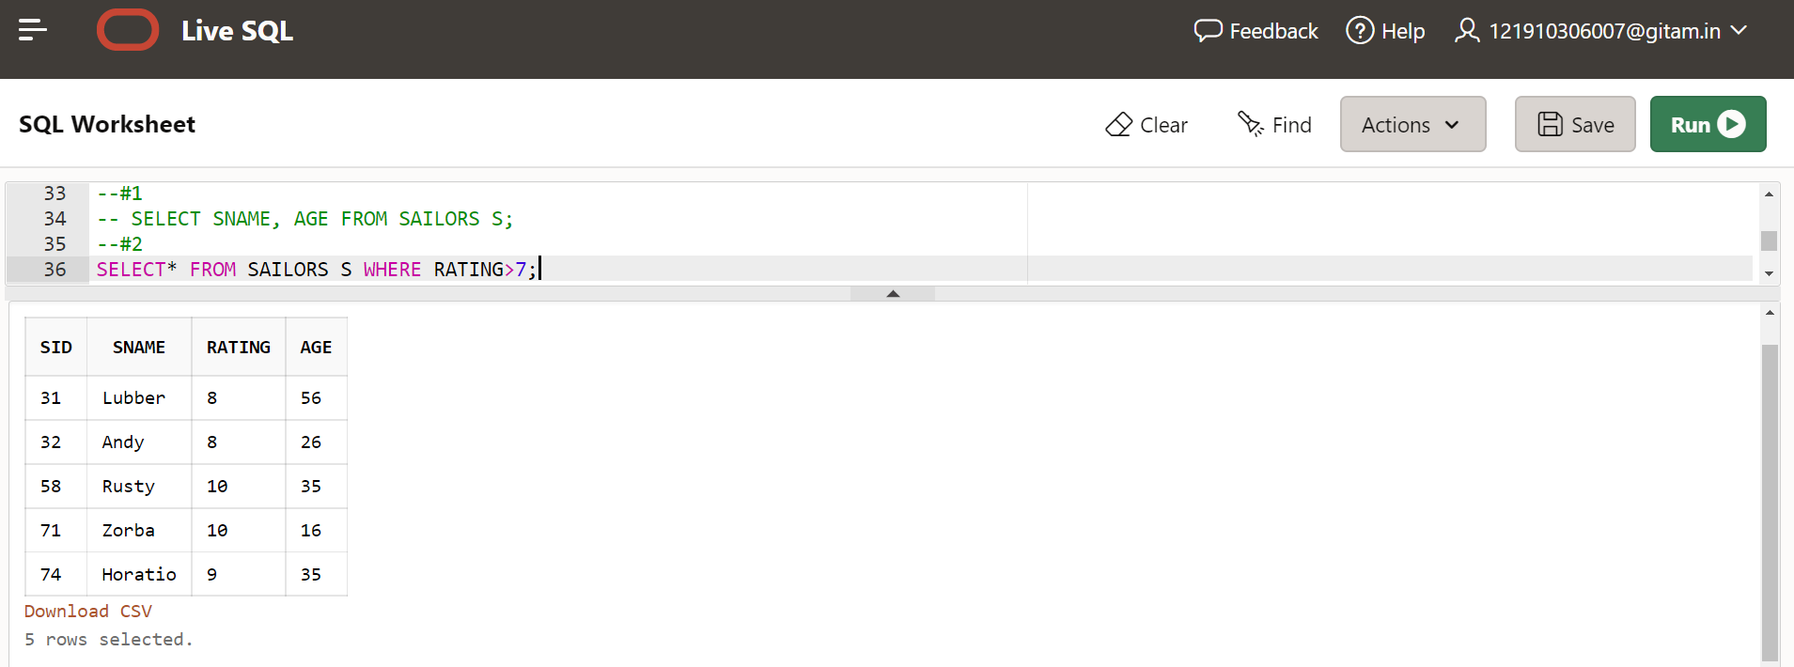

**3) Find the Sids of sailors who have reserved a Blue Boat?**

**SELECT R.SID**

**FROM RESERVES R, BOATS B**

**WHERE R.BID=B.BID AND B.COLOR='blue';**

**Output:**

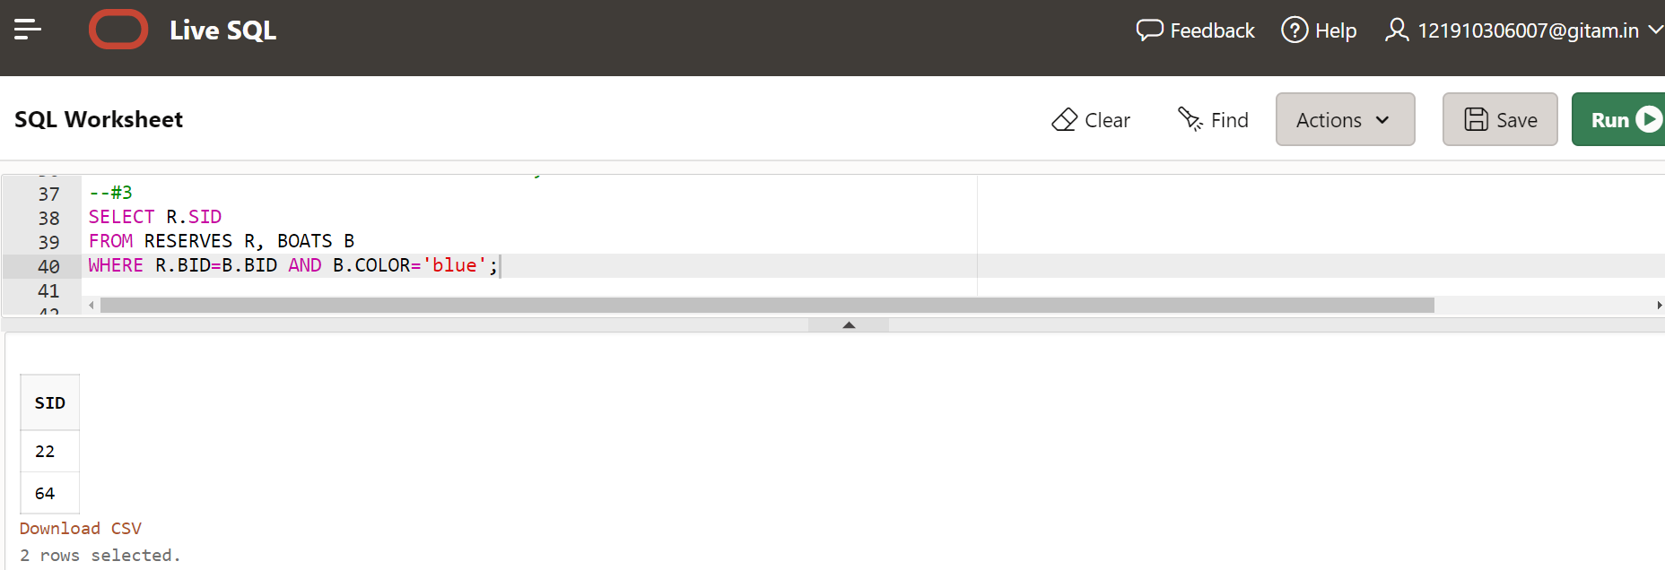

**4) Find the Names and sids of sailors who have reserved a Blue Boat?**

**SELECT SNAME, R.SID**

**FROM SAILORS S, RESERVES R, BOATS B**

**WHERE S.SID= R.SID AND R.BID=B.BID AND B.COLOR='blue';**

**Output:**

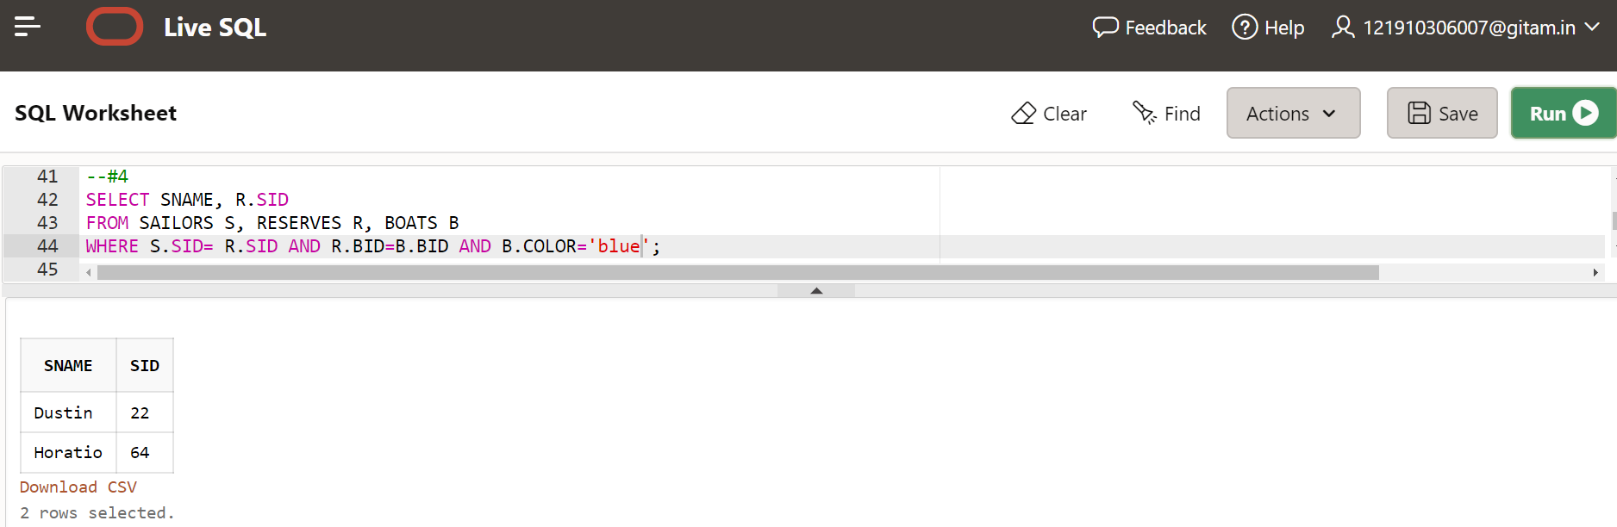

**5) Find the colors of Boats reserved by Dustin ?**

**SELECT B.COLOR**

**FROM SAILORS S, RESERVES R, BOATS B**

**WHERE S.SID= R.SID AND R.BID=B.BID AND SNAME='Dustin';**

**Output:**

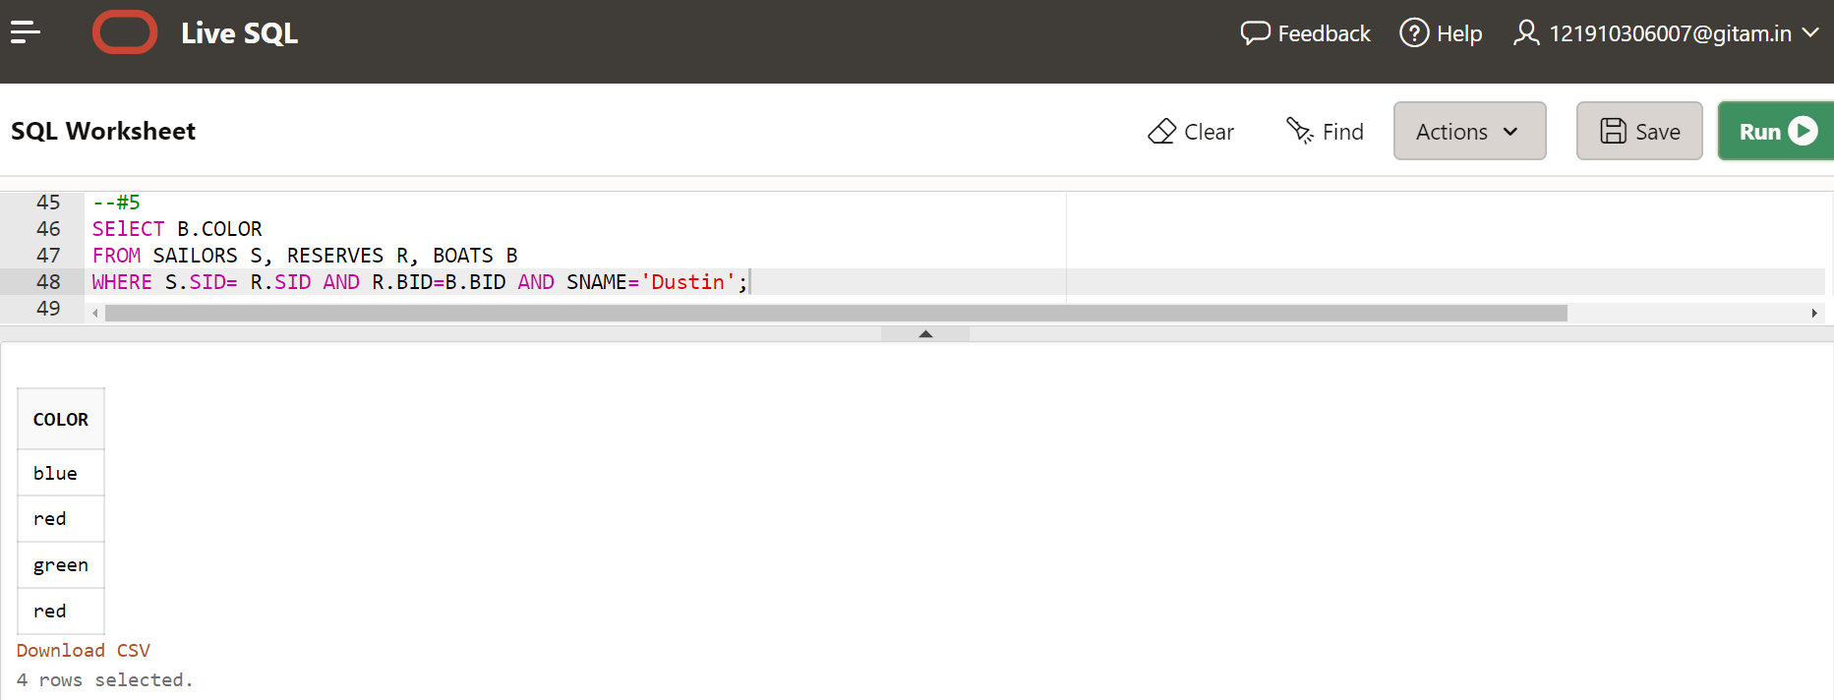

**6) Find the Names of sailors who have reserved at least one boat?**

**SELECT DISTINCT SNAME**

**FROM SAILORS S, RESERVES R**

**WHERE S.SID=R.SID;**

**Output:**

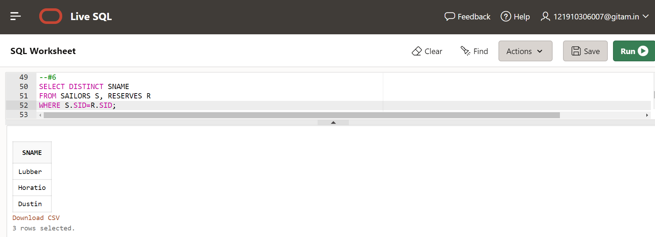

**7) Find the Names of sailors who have reserved a Blue or Green Boat?**

**SELECT SNAME**

**FROM SAILORS S, RESERVES R, BOATS B**

**WHERE S.SID= R.SID AND R.BID=B.BID AND B.COLOR='blue'**

**UNION**

**SELECT SNAME**

**FROM SAILORS S, RESERVES R, BOATS B**

**WHERE S.SID= R.SID AND R.BID=B.BID AND B.COLOR='green';**

**Output:**

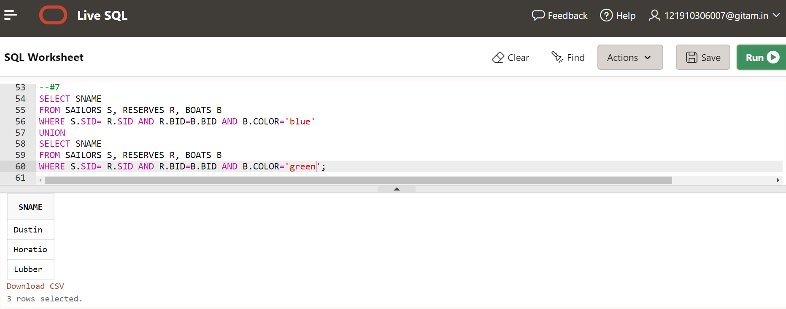

**8) Find the sids of all sailors who have reserved red boats but not green boats?**

**SELECT R.SID**

**FROM RESERVES R, BOATS B**

**WHERE R.BID=B.BID AND B.COLOR='red'**

**MINUS**

**SELECT R.SID**

**FROM RESERVES R, BOATS B**

**WHERE R.BID=B.BID AND B.COLOR='green'**

**Output:**

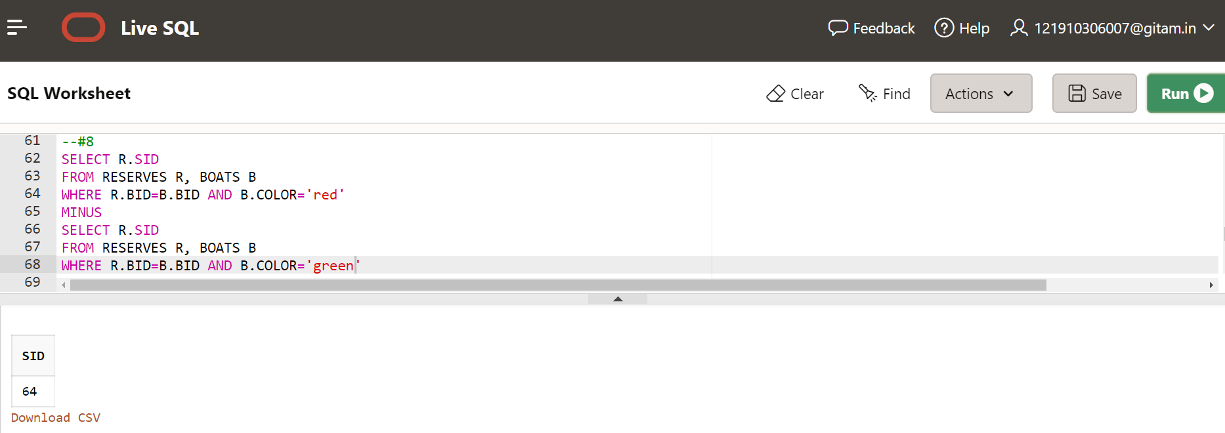

**9)Find all sids of sailors who have a rating of 10 or reserved boat 104?**

**SELECT SID**

**FROM SAILORS**

**WHERE RATING=10**

**UNION**

**SELECT R.SID**

**FROM RESERVES R,BOATS B**

**WHERE R.BID=B.BID AND B.BID=104;**

**Output:**

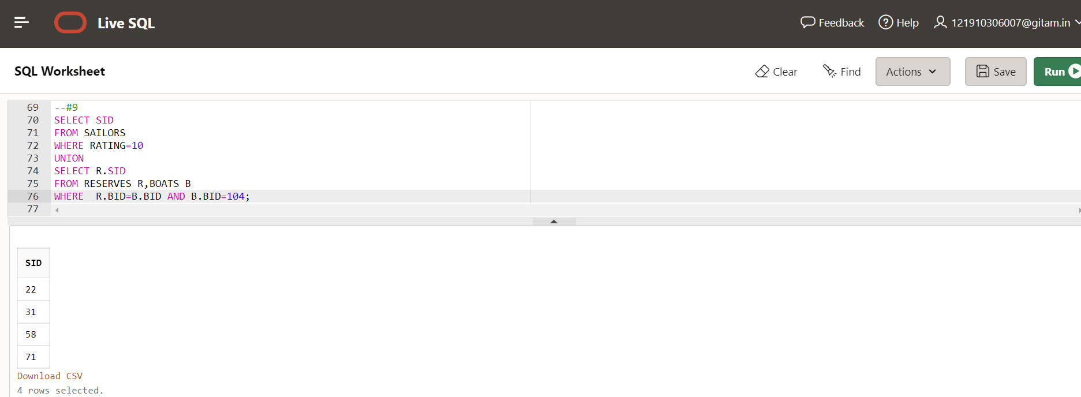

**10)Compute increments for the ratings of Persons who have sailed two different boats on the same day?**

**SELECT DISTINCT SNAME, RATING+1**

**FROM SAILORS S, RESERVES R1, RESERVES R2**

**WHERE S.SID=R1.SID AND S.SID=R2.SID AND R1.DAY=R2.DAY AND R1.BID<>R2.BID;**

**Output:**

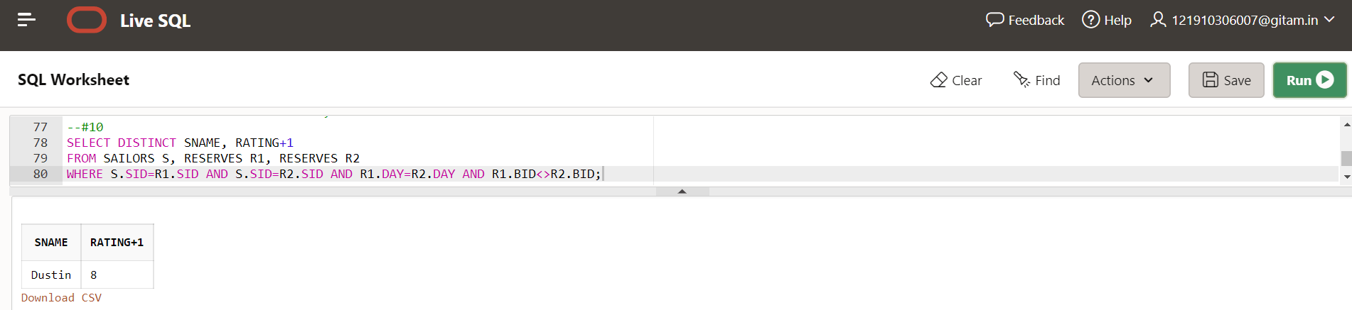

**11)Find the Names of sailors who have reserved both Blue and Green Boat?**

SELECT SNAME

FROM SAILORS S, RESERVES R, BOATS B

WHERE S.SID= R.SID AND R.BID=B.BID AND B.COLOR='blue'

INTERSECT

SELECT SNAME

FROM SAILORS S, RESERVES R, BOATS B

WHERE S.SID= R.SID AND R.BID=B.BID AND B.COLOR='green';

**Output:**

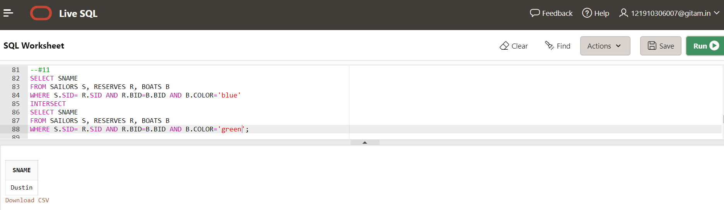

**12)Find the sids and sname of sailors who have a age 35 or reserved green boat?**

SELECT SID,SNAME

FROM SAILORS

WHERE AGE=35

UNION

SELECT R.SID, SNAME

FROM SAILORS S, RESERVES R, BOATS B

WHERE S.SID= R.SID AND R.BID=B.BID AND B.COLOR='green';

**Output:**

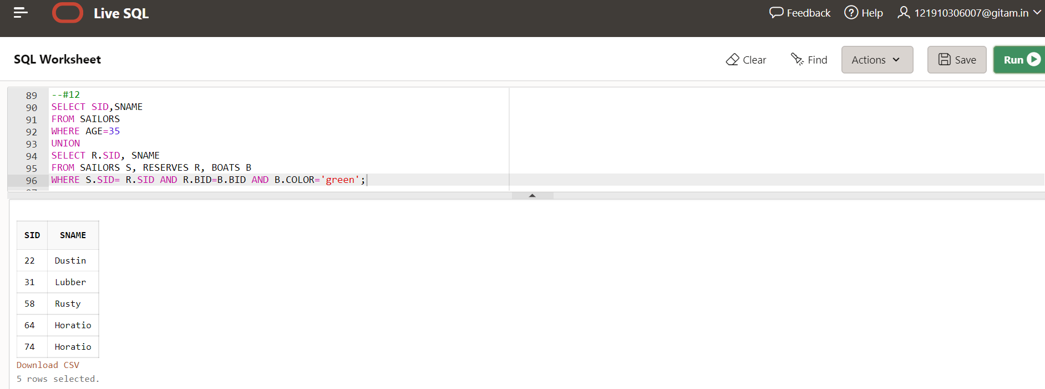

**13)Find the sname of all sailors who have reserved either Boat 102 or Boat 104?**

SELECT DISTINCT SNAME

FROM SAILORS S, RESERVES R

WHERE S.SID = R.SID AND (R.BID = 102 OR R.BID=104);

**Output:**

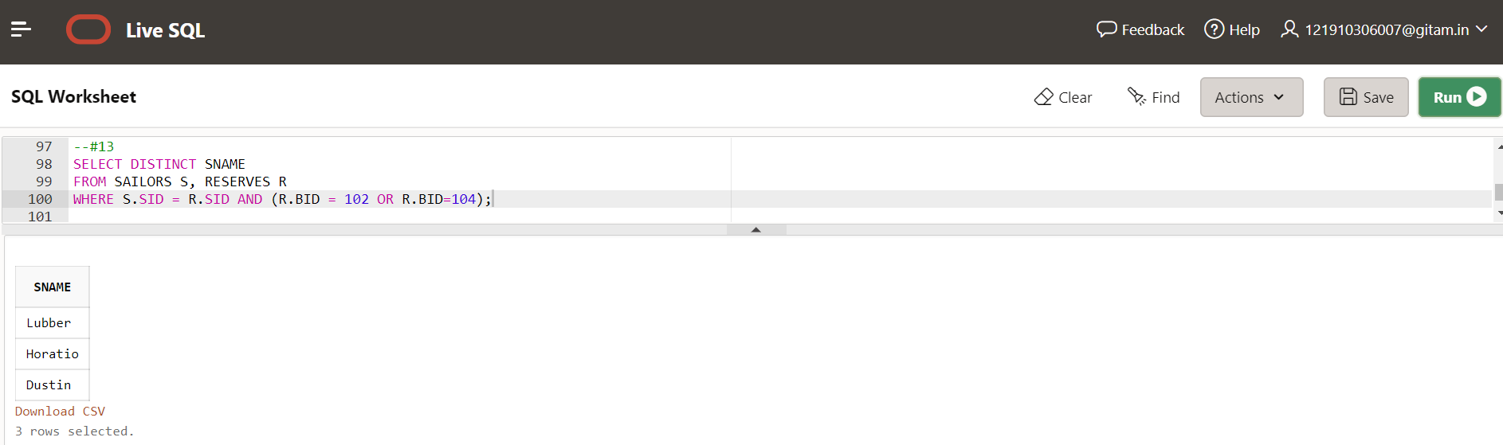

**14) ADD A COLUMN ADDRESS TO SIALORS DATABASE AND Update the values of address attribute?**

**Step-1: Address column added to sailors table**

**ALTER TABLE SAILORS**

**ADD ADDRESS VARCHAR(10);**

**Output:**

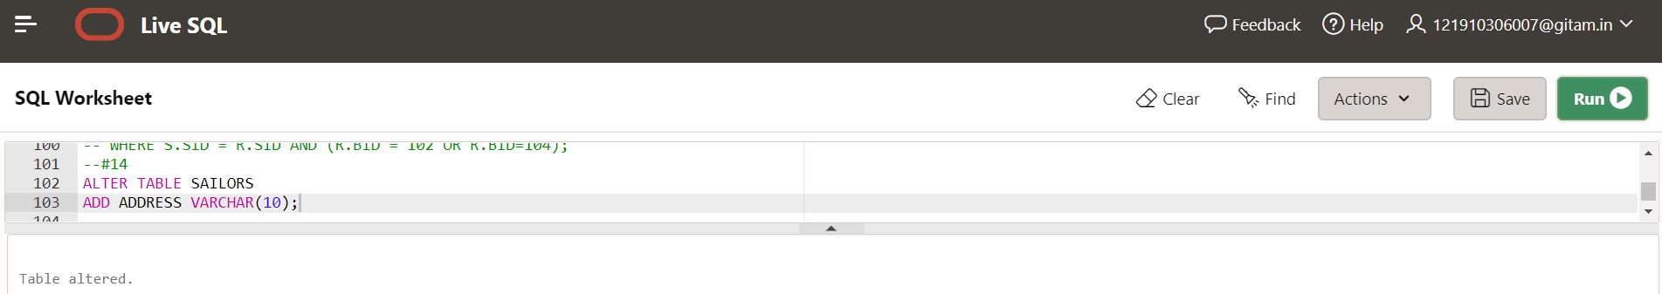

**Step-2: Updated values of address attribute**

UPDATE SAILORS SET ADDRESS='London' where SID='22';

UPDATE SAILORS SET ADDRESS='India' where SID='29';

UPDATE SAILORS SET ADDRESS='Ireland' where SID='31';

UPDATE SAILORS SET ADDRESS='UK' where SID='32';

UPDATE SAILORS SET ADDRESS='Srilanka' where SID='58';

UPDATE SAILORS SET ADDRESS='China' where SID='64';

UPDATE SAILORS SET ADDRESS='Paris' where SID='71';

UPDATE SAILORS SET ADDRESS='Australia' where SID='74';

UPDATE SAILORS SET ADDRESS='Japan' where SID='85';

UPDATE SAILORS SET ADDRESS='USA' where SID='95';

**Output:**

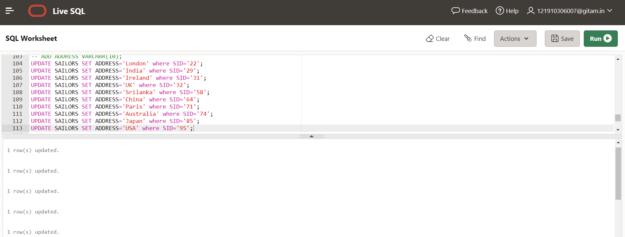

**Step-3: Display updated SAILORS table**

**SELECT * FROM SAILORS;**

**Output:**

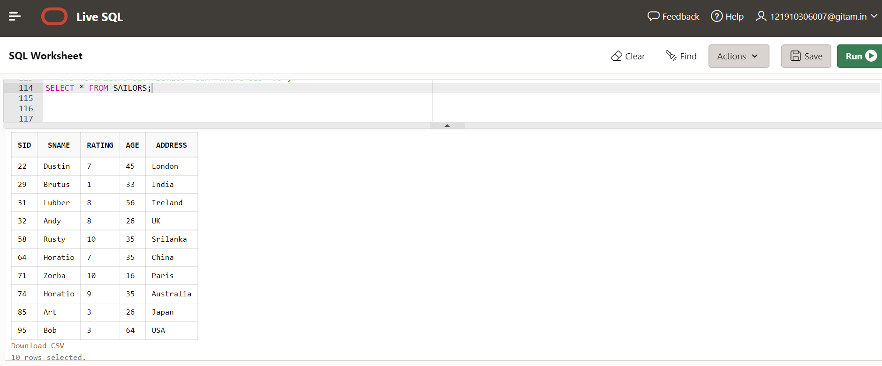

**15) Delete A Tuple with name ‘ZORBA’ and Modify the Column Name Rating with srating**

DELETE FROM SAILORS WHERE SNAME='Zorba';

ALTER TABLE SAILORS RENAME COLUMN RATING TO SRATING;

**Output:**

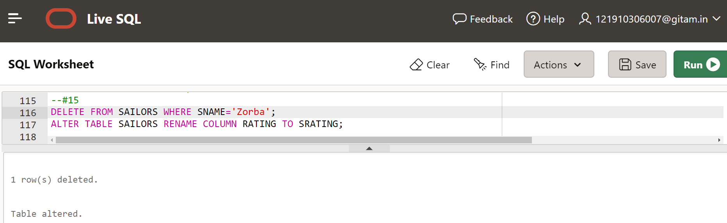

**Display SAILORS table:**

